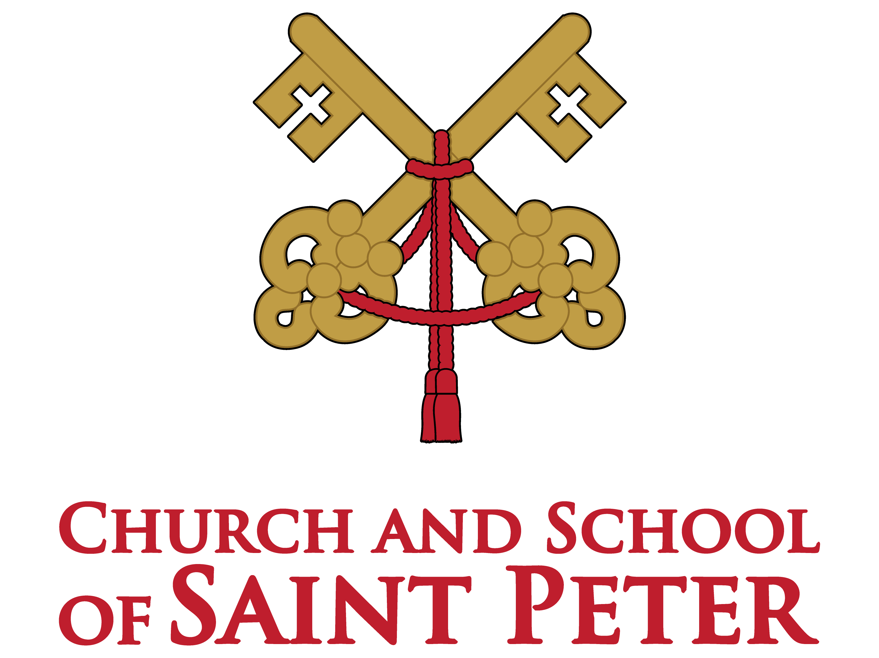
Message from the Pastor

Church of Saint Peter

“If one member suffers in the body of Christ which is the Church, all the members suffer with that member.”
1 Corinthians 12:26

Dear Parishioners and Family Members,

Of all life’s experiences, the death of a loved one is often the most difficult and challenging thing to face. The Church of Saint Peter sincerely understands the pain and sorrow endured by families at this time. We offer our deepest sympathy and remember your loved one and your family in prayer. We also want to assist you in planning the funeral service and burial for your loved one. Our hope is that the information contained in this packet will help you in doing that and bring comfort
to you and your family during this
difficult time.

May God bless you,

Fr. Daniel Bodin, Pastor
Contact Information
Directory

Parish Office:
651-982-2200

Parish Office Fax:
651-982-2220

Director of Music/Liturgy:
651-982-2224

Director of Pastoral Care:
651-982-2229

Calvary Cemetery:
651-982-2200

Local (Forest Lake)
Funeral Home Information
(listed in alphabetical order)

Mattson Funeral Home
and Cremation Service
343 North Shore Drive
Forest Lake, MN 55025
Phone: 651-464-3556
www.mattsonfuneralhome.com

Roberts Family
Funerals, Cremations, Celebrations
A Life Celebration Home
555 Centennial Drive SW
Forest Lake, Minnesota
Phone: 651-464-4422
www.robertsfamilyfh.com
Funeral Liturgies/Visitations
Fees / Visitations / Liturgy

Fees:
All fees are collected by the funeral home.

- Church Liturgy: $200.00
- Includes:
- A visitation prayer service (upon request)
- Organist/pianist
- Funeral Choir (upon request)
- Soloist/Cantor (upon request): $100.00

- Funeral Home Liturgy: $250.00
  - Includes:
- A visitation prayer service (upon request)
- Liturgy of the Word
- Soloist/Cantor (upon request): $100.00
- Organist/Pianist (upon request): $125.00

- With the assistance of a funeral home
  - No charge for use of the Gathering Space
  - The funeral home staff is responsible for transporting and securing the remains of the deceased before, during, and after the
visitation
  - The funeral home staff must be in attendance during the visitation
- Without the assistance of a funeral home
  - Fee of $150.00
  - The family is responsible for transporting and securing the remains of the deceased before, during, and after the visitation
  - A St. Peter’s staff person will be on the premises
- Evening before the funeral
  - Use of the Gathering Space is subject to availability.
  - Visitation hours are 4:00 pm – 8:00 pm
- The morning of a Funeral Liturgy
  - No additional charges
  - Visitation hours are 10:00 am - 11:00 am

- Liturgy Times:
The standard funeral time is 11:00 am,
Monday through Saturday
Liturgy Planning
Liturgy Planning

When a loved one has passed away the Church of St. Peter is here to assist you with the details of planning a funeral liturgy and burial.

At the planning meeting, the music and readings will be selected. Resources will be available to assist you in making
the selections. The planning meeting is a time to talk about participants in the funeral. It is also a time for the family to share memories of their loved one to assist the clergy in preparing the homily.

Selections to be made by the family:

Readings:
First Reading
Second Reading
Gospel Reading

Music:
Prelude
Gathering Hymn
Responsorial Psalm
Hymn for the Preparation of the Gifts
Communion Hymn
Recessional Hymn

Liturgical Roles:
(May be filled by family members or friends:)
Placing the Pall
1st Reading
2nd Reading
Intercessions
Gift Bearers
Food / Hospitality
Food / Hospitality

A luncheon, served at the Church of St. Peter, is available as an optional service to the family for a minimal cost. The meal is usually served following the committal service at the cemetery unless prior arrangements have been made in advance.

Serving alcohol is prohibited. The funeral director will help the
family determine the number of expected guests. The family will be charged for the estimated number of guests to be served or for the actual number served—whichever is greater.

All food and paper products are included. Food will be prepared
and served by volunteers, under the supervision of a licensed
kitchen manager.

Pasta Meal - $7.00 per person
- Pasta, Marinara with Sweet Italian Sausage Links
- Broccoli
- Italian Bread Assortment
- Dessert
- Coffee/Lemonade/Water

Cold Meal - $7.00 per person
- Sliced Cold Ham/Turkey with Buns
- Potato Salad
- Fresh Fruit Tray/Baked Beans (Seasonal)
- Potato Chips
- Dessert
- Coffee/Lemonade/Water

Please note: A meatless meal will be served on Fridays during Lent.
All remaining food will be packaged and sent home with the family. However, arrangements may be made with the Pastoral Care Department to distribute the food to those in need.
Outside Catering
Outside Catering

We recognize that our menu options may not always meet the needs of everyone. Therefore, families are welcome to use a catering service, delicatessen, or restaurant.
Please note that we are a licensed kitchen, and the following guidelines must be followed:

- Food must be furnished through a licensed and insured food supplier such as a local catering firm, deli, or restaurant.
- Beverages are to be provided by the caterer/family or St. Peter’s will supply beverages for a small fee.
- Food that is prepared in private homes or kitchens may not pass through our kitchen. These items must be taken directly to and served from the room in which the meal will be served.
- Food may be prepared on site in our kitchen or transported to the site following safe food transportation requirements established by the Minnesota Department of Health.
- A certificate of liability insurance in the amount of $1 million must be supplied, along with a copy of the food service license.
- The certificate of liability insurance must list the Church of Saint Peter as an additional insured party.

The family will work directly with their caterer to provide all food items, paper products. The Church of St. Peter will ensure the room is furnished with tables and chairs.

There are no fees for the use of the kitchen and/or dining room for funeral lunches.
Frequently Asked Questions
Frequently Asked Questions

What about burial?
Typically, a burial follows the funeral liturgy. Burial is scheduled according to the requirements of the cemetery chosen by the family. A representative from the Church of
St. Peter will accompany the family to the cemetery. The Rite of Committal does not require a priest and may also be done by a deacon or a lay person.

Is Cremation allowed?
In the event of a cremation, the Church recommends that the body first be brought to the Church for the Mass and cremated at a later time. Under certain circumstances, cremation may take place prior to the church service. The cremated remains, by Church Law, must be treated as the body is treated; placed in a worthy container and interred or entombed wholly in a proper, consecrated resting place (cemetery). Due to the reverence given to our mortal bodies, the Church does not allow scattering the ashes or keeping all or a portion of the ashes by family or friends. Burial of the remains should be within 6 months of death. If cremation has taken place without the assistance of a funeral home, the Church of St. Peter encourages that a Funeral Director be involved to assist in the funeral service.

Who can receive Holy Communion in the Catholic Church?

For Catholics:
When we receive Holy Communion, we present ourselves as being in union with the Catholic Church which entails regularly practicing the Catholic faith and following the teachings of the Catholic Church. We are encouraged to receive Communion devoutly
and frequently. In order to be properly disposed to receive Communion, one should not
be conscious of grave sin and normally should have fasted for one hour before Communion.

For Non-Catholics:
We welcome our non-Catholic brothers and sisters to come forward during Communion for a blessing rather than receiving Holy Communion. Simply place your hands across your chest when approaching the priest or Extra Ordinary Minister of Holy Communion.
If you prefer you may remain in the pews during this time.

What about music?
The Catholic Funeral Liturgy is patterned after the Sunday Liturgy. The Assembly is
called to actively participate in the readings and sacred hymns. Due to the sacredness of the funeral, secular music is not allowed, nor is pre-recorded music permissible. A list of suggested music will be provided at the liturgy planning meeting. Musicians are provided by the Church of St. Peter. For any special requests regarding music or musicians, please contact the Director of Music.
After Care
After Care

Grief Ministry
Our Pastoral Care Department offers Seasons of Hope, a bereavement ministry program designed to support those who have experienced the death of a loved one.

Annual Mass of Remembrance
Annually there is a Mass of Remembrance in honor of those loved ones who have gone before
us in the past year. Invitations are mailed out to your designated family contact. All family members and friends are welcome to attend.
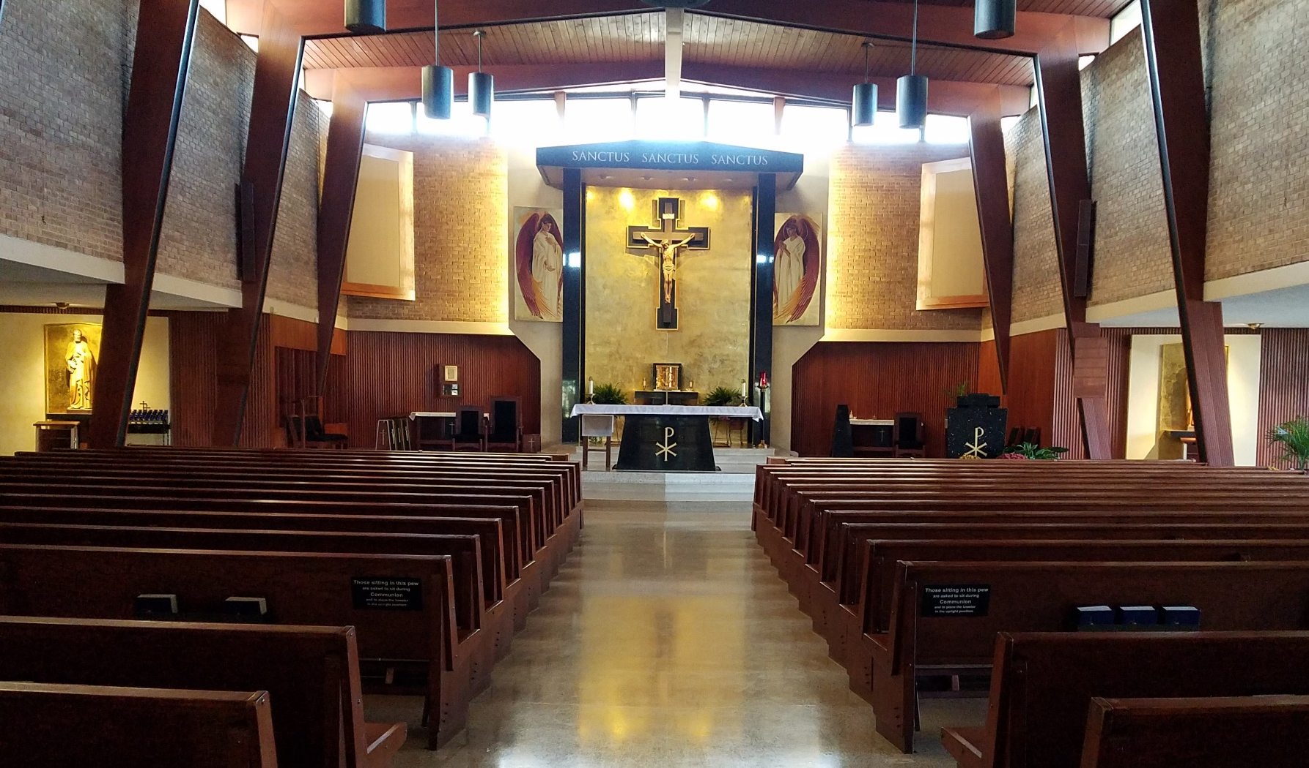
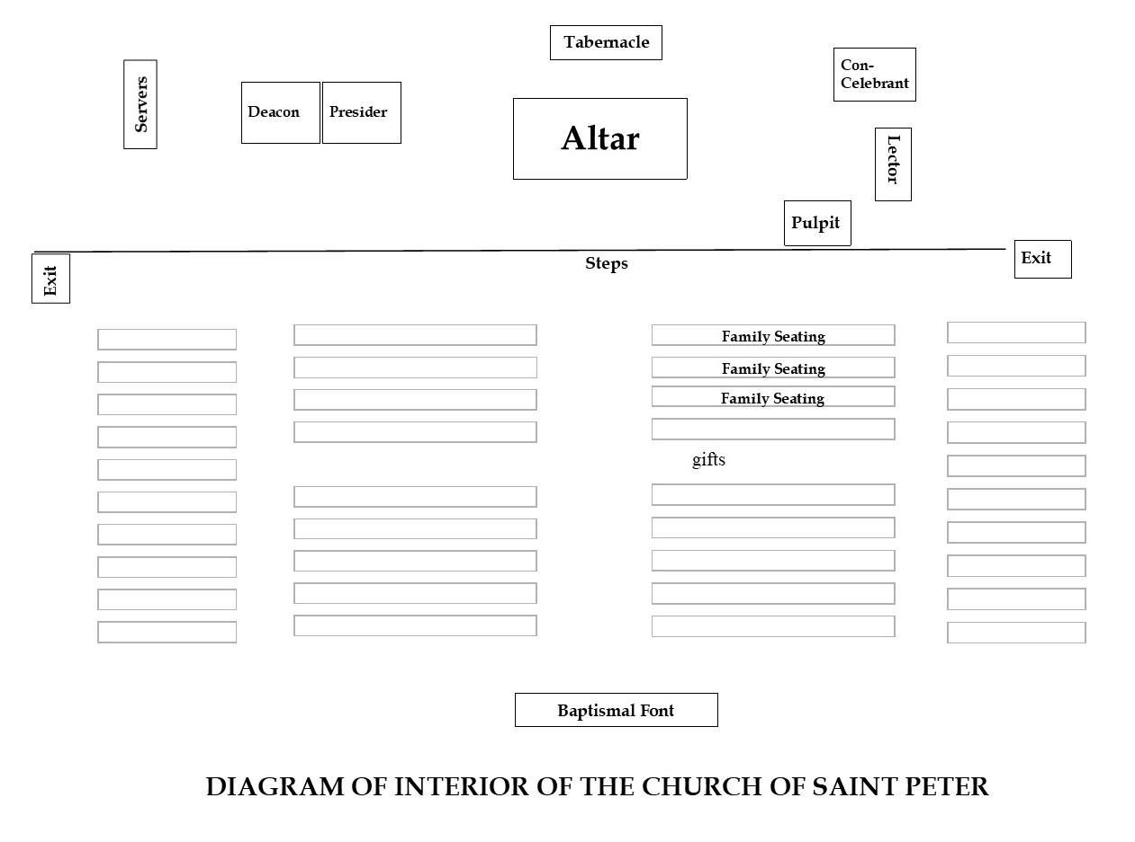
Interior of the Church

